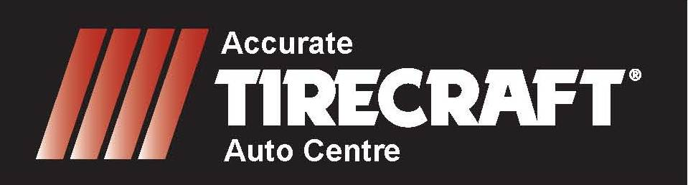

***MAINTENANCE PACKAGE***

***Unlike most lube shops a technician will:***

**Change oil & filter (up to 5L conventional oil)**

**Tire inspection & rotation**

**Check fluid levels and condition**

**Check antifreeze/coolant**

**Check belts & hoses**

**Check steering/suspension**

**Check exhaust system**

**Check lights**

**Brake inspection**

**$99.95**

**NEW CAR WARRANTY APPROVED**

***MOST CARS/LIGHT TRUCKS ENVIRO FEE EXTRA***